SF2210 Operator’s Manual

<Product name and version number>

Author | Xu Fei | West Tower of Baidu International Building, Yuehai Sub-district, Nanshan District, Shenzhen  Official website: www.sinsegye.com.cn  E-mail: Sales@sinsegye.com.cn  Hotline: 400-013-2158
Date | January 14, 2025
Version | V1.0
Email | xufei@sinsegye.com.cn

Update Instructions
This paper records the change in SF2210 vision operator library.
Function | Type of Change | Description | Related Documents
- Realize the picture transmission function of the iComputer  - Provide a camera service operator library, a basic vision operator library and a time series operator library |  |  | SF2210 Operator Library Interface Description (Chinese Version)-v20241129.docx

Introduction to SF2210

Preface

I. Document Description
The instructions have been developed for technical experts in control and automation, who are familiar with the relevant national standards and who have received professional training.
Please carefully read all relevant documents and the following instructions when installing and commissioning components.
Qualified personnel should always operate it according to the latest available documentation.
The responsible person must ensure that the application or use of the product described is in full compliance with all safety requirements, including all relevant laws, regulations, guidelines and standards.
1. Disclaimer
This document has been carefully prepared, but in view of the ongoing development and upgrading process of the products described, Sinsegye (Shenzhen) Computer System Co., Ltd. reserves the right to modify and update the document at any time without prior notice. Please note that any changes to the delivered products based on the data diagram and the description in this document are prohibited.
Sinsegye Computer System Co., Ltd. shall not be liable for any loss or damage resulting from the use of or reliance on the information contained or not indicated in this manual.
2. All rights reserved.
The ownership of this manual belongs to Sinsegye Computer System Co., Ltd. This manual shall not be reproduced, distributed, translated or used in any form, in whole or in part, without written permission.
This manual is protected by copyright law. Any reproduction, distribution, translation, presentation, performance, interpretation or use of the contents of this manual for any purpose is subject to the express permission of Sinsegye Computer System Co., Ltd. Without permission, any act shall be deemed to infringe the copyright of Sinsegye Computer System Co., Ltd.

II. Safety Statement
1. Safety regulations
For your safety, please read the following instructions. You always follow the product-specific safety instructions, which you can find in the appropriate place in this document.
2. Exclusion of liability
All components are provided with hardware and software configurations. It is not allowed to modify the hardware or software configuration not described in the document, and Sinsegye shall not be responsible for the hardware or software not described in the document.
3. Qualification of personnel
The instructions are intended solely for trained technical experts in control, automation and actuation, who are familiar with the applicable national standards.
4. Signal words
The signal words used in the document are classified as follows. To prevent injury and damage to people and property, please read and observe the safety and warning notices.
5. Personal injury warning
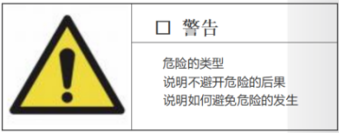 | Warning indicates a potentially hazardous situation that, if not avoided, may result in serious injury or death.
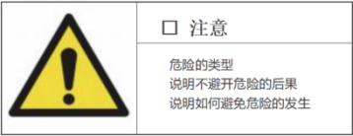 | Caution indicates a potentially hazardous situation that, if not avoided, may result in minor or moderate injury, or damage to the equipment.
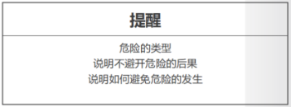 | Caution indicates a potentially hazardous situation that, if not avoided, may only result in damage to the equipment.
6. Warning of damage to property or the environment
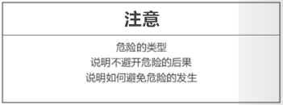 | Environment, equipment, or data may be damaged.
7. Product processing information
For example, this information includes proposals for action, assistance or further information about the product.

Overview
SF2210 includes two parts: file source and vision operator: the file source software can realize the picture transmission function with the iComputer, and the function is subsequently integrated into IDE and does not need to be downloaded and used separately; the vision operator library provides the interfaces called by the camera service operator library, the basic vision operator library and the time series operator library in MateFacture, and these interfaces provide a way to realize the operation of the camera and the processing of the image and time series in the PLC project through ST script.

The following table provides an overview of the product components
Product Components | Description
libacp_0.2.2-beat_amd64.deb | ACP Service Component
sicomputervisionop_0.0.0-filelian2d06c307_amd64.deb | SF2210 (Document Source + Vision Operator) Service Component
SF2210_Vision_1.0.1.1.library | IDE-side library file (file source + visual operator)
TestSF2210_lian_new_lib.project | IDE-side test sample file
FileSource.rar | File source software
PICS.rar | Test case pictures

Installation and Uninstallation

I. Installation Requirements
Before the installation, please read the operation example in basic operations of linux.
- Self-contained system of the iComputer produced by Sinsegye;

II. Installation Process
1. Install ACP service components and SF2210 service components
- Upload the deb package to the /home/sinsegye directory in the Linux environment of the iComputer
- After uploading, execute the installation command on the iComputer (Refer to the screenshot below. If the module file name is changed, the file name in the command line will be changed accordingly)
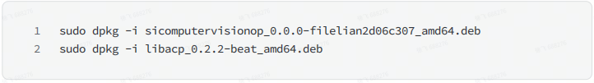
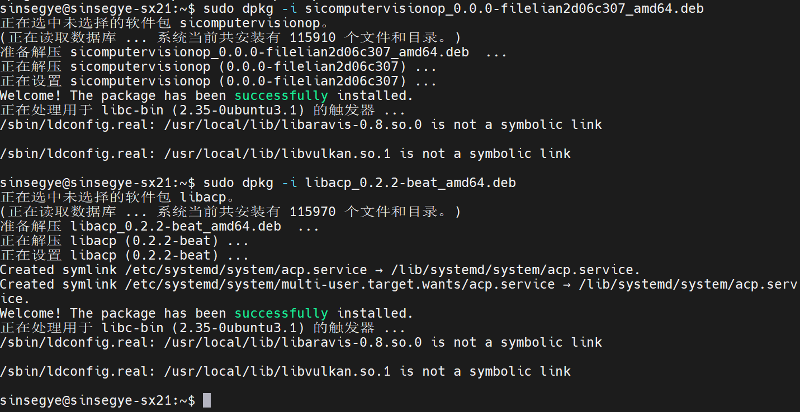
2. Modify the configuration file of RTE, and add sicomputervisionop under the ComponentManger module (only the green part needs to be added, and the specific serial number needs to be changed according to the actual situation).
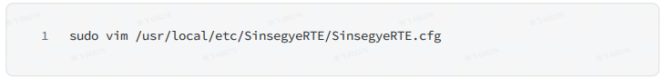
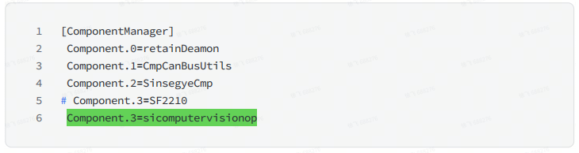
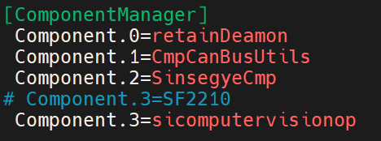
- Restart the RTE service to call the newly added sicomputervisionop.
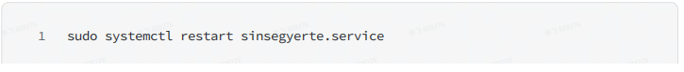
3. Deploy the library of SF2210 on the IDE side.
- In MetaFacture, click the top menu bar "Tools" -- "Library Storage"
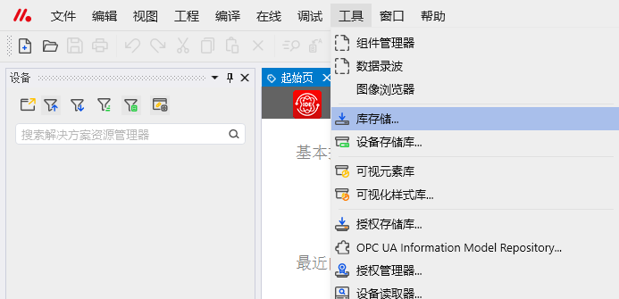
- Click "Install" in the pop-up dialog window – double-click SF2210_Vision_1.0.1.1.library
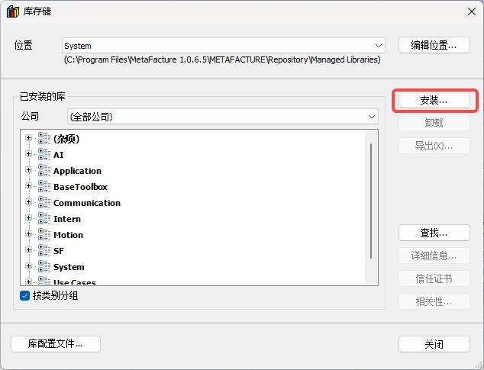
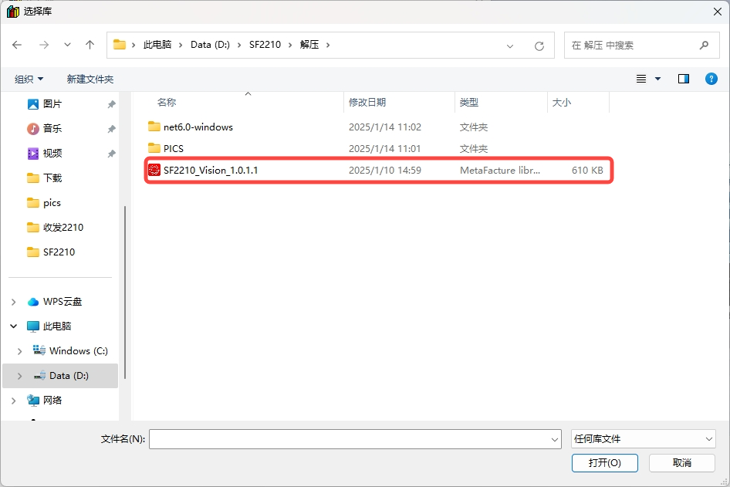
- In the project, double-click "Library Manager" -- "Add Library" -- click “Miscellaneous” -- double-click "SF2210_Vision" to load the library.
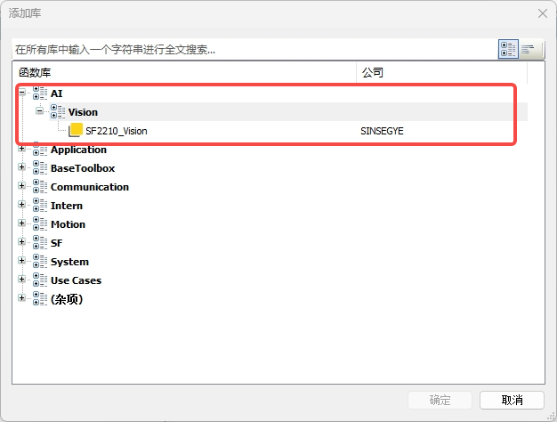

III. Updating and Installation
1. Upgrade ACP service component and SF2210 service component at the iComputer
- Upload the updated deb package to the /home/sinsegye directory in the Linux environment of the iComputer, and refer to the appendix for the uploading method;
- After uploading, execute the installation command on the iComputer (Refer to the screenshot below. If the module file name is changed, the file name in the command line will be changed accordingly)
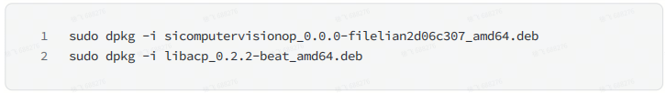
- Restart the RTE service to call the newly upgraded SF2210
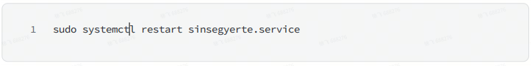
2. Upgrade the library of SF2210 on the IDE side.
- In MetaFacture, click the top menu bar "Tools" -- "Library Storage"
- Click "Install" in the pop-up dialog window -- select SF2210_Vision_1.0.1.1.library -- click "Open"
- In the project, double-click "Library Manager" -- "Add Library" -- click “Miscellaneous” -- double-click "SF2210_Vision" to load the library.

IV. Uninstallation Process
1. Uninstall ACP service component and SF2210 service component from the iComputer
- Execute the uninstallation command on the iComputer
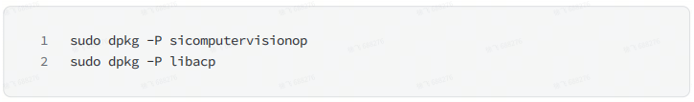
- Modify the configuration file of RTE, and delete sicomputervisionop from the ComponentManger module.
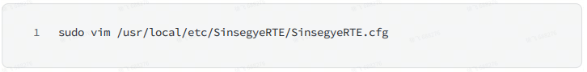
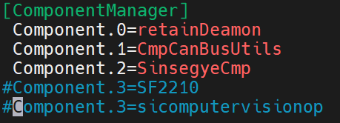
- Restart the RTE service
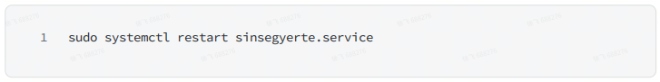
2. Unload the library of SF2210 on the IDE side.
- In the MetaFacture interface, click on "Tools" -- "Library Storage"
- In the dialog box, select the installed SF2210_Vision library and click “Uninstall”

Technical Description

I. Quick Start

(I) Software and hardware configuration of this example
Hardware:  - SX21 one-layer virtualization  - Win11Pc | Software:  - MetaFacutre V1.0.6.5  - MobaXterm_Personal_23.2  - FileSource

(II) Experimental operation steps of this example

1 Experimental requirements
a. Successfully install the ACP service component and the SF2210 service component at the iComputer and correctly modify the configuration file.
b. Successfully install SF2210_vision.library on MetaFacture

2 Schematic Diagram of the Experiment

3 Experimental procedures
You can refer to TestSF2210_lian_new_lib.project in the product component for this experiment

1. Unzip FileSource and then open it
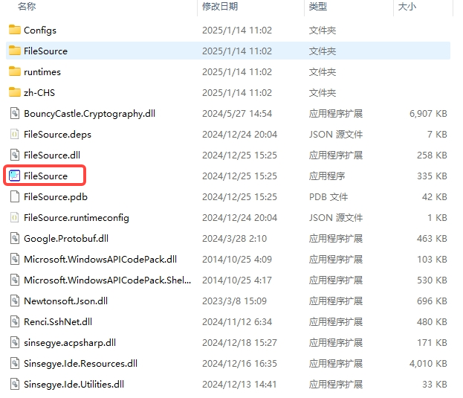

2. Click VISION--New FileSource, and input Name and TargetId (Name can be input arbitrarily, and TargetId is the IP of the iComputer)
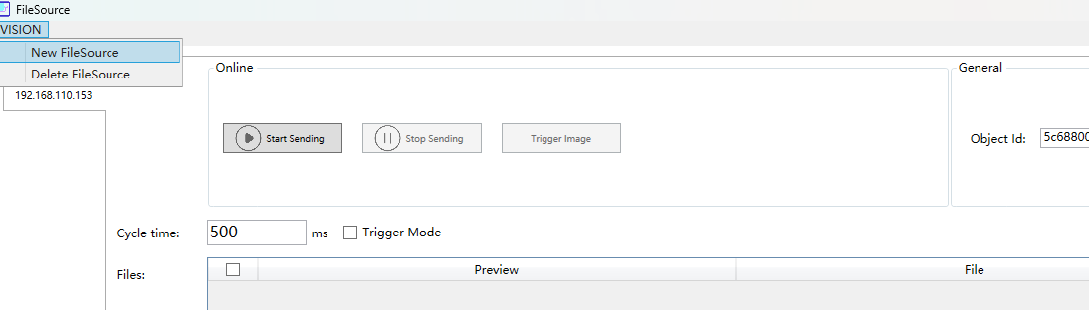
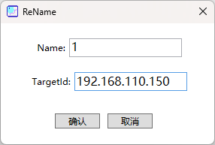

3. Add the test picture file, set the picture Fortmat to RGB24, click “send data”, and a prompt will be displayed after success - the photo source is updated successfully.
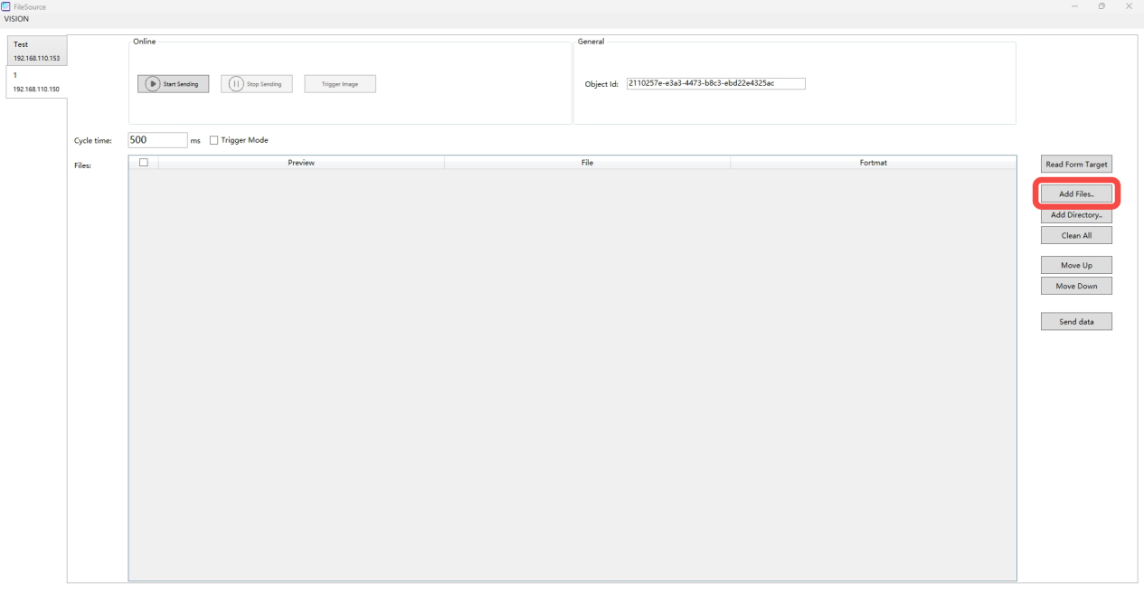
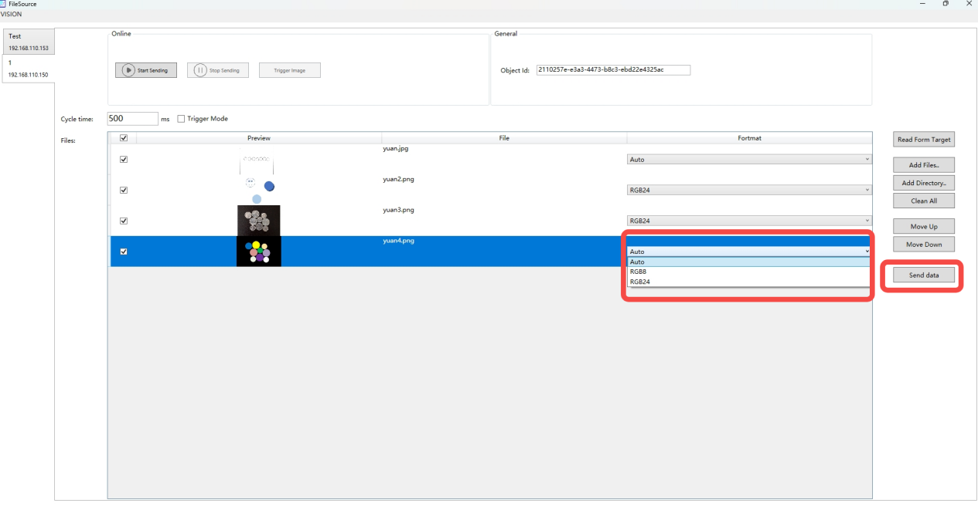
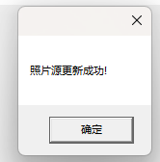

4. Copy the Object Id in FilesSource and use it in subsequent projects.
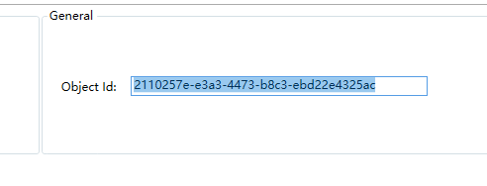

5. Open the test project file TestSF2210_lian_new_lib.project, and modify the variables related to Object Id in the program according to the contents in Step 4
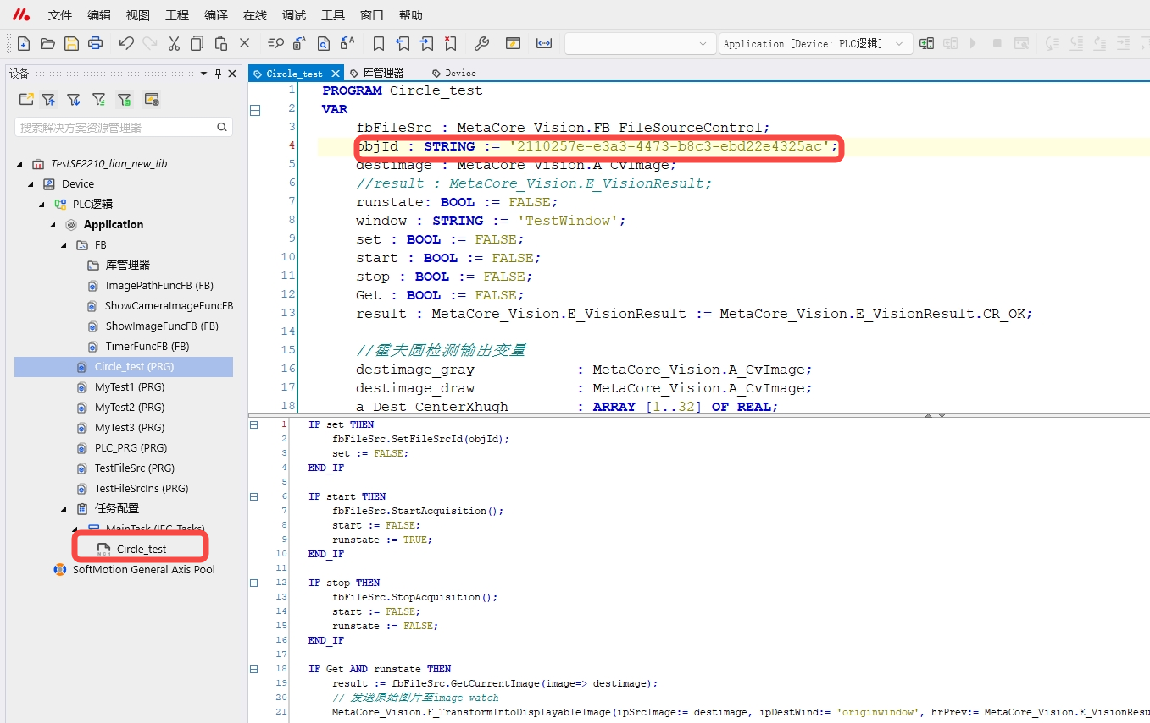

6. Enter the Device option, select the iComputer and log in.
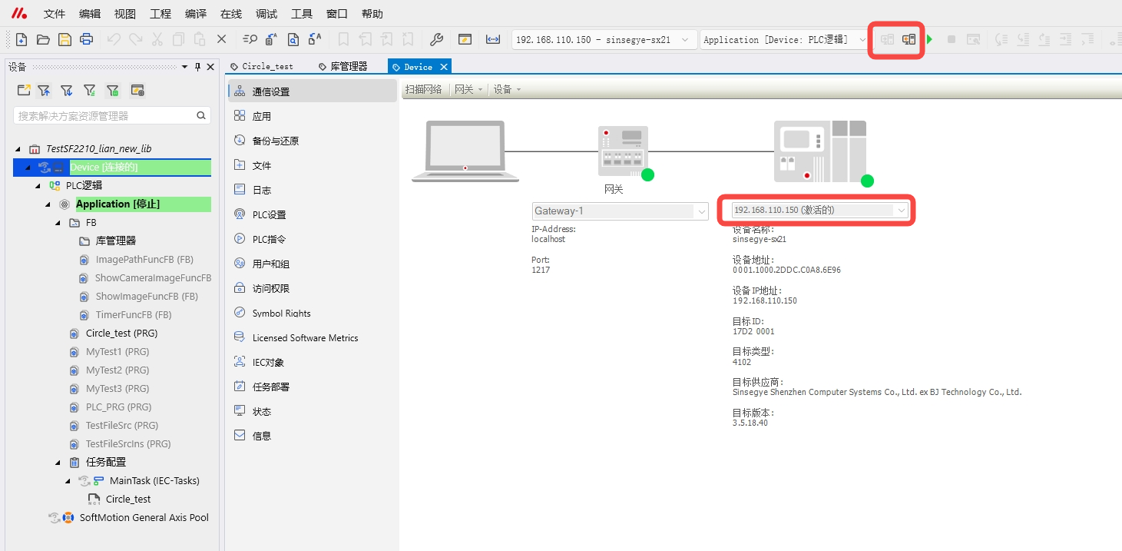

7. Click “Run” and enter the program to perform the following operations:

a. Set the variable “set” to true to ensure that objId is configured correctly.
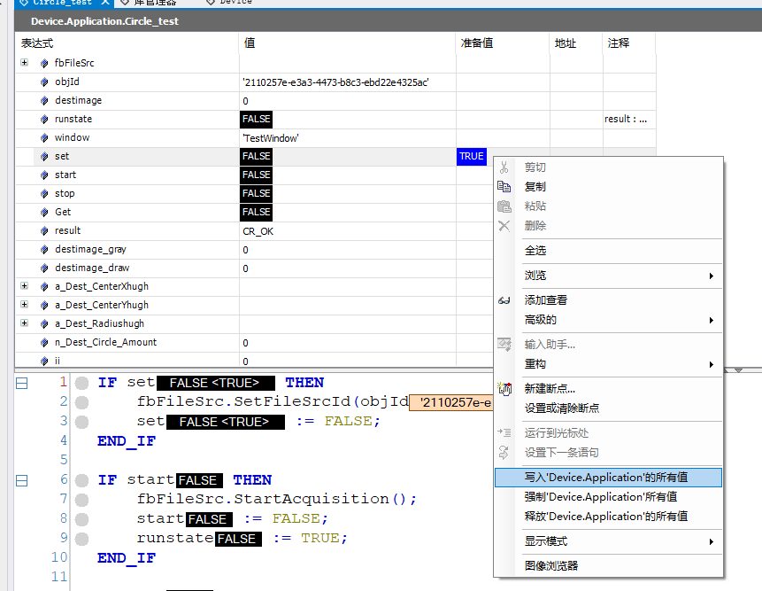

b. Set the variable “start” to true to open the file source; You can also control start/stop on FileSource
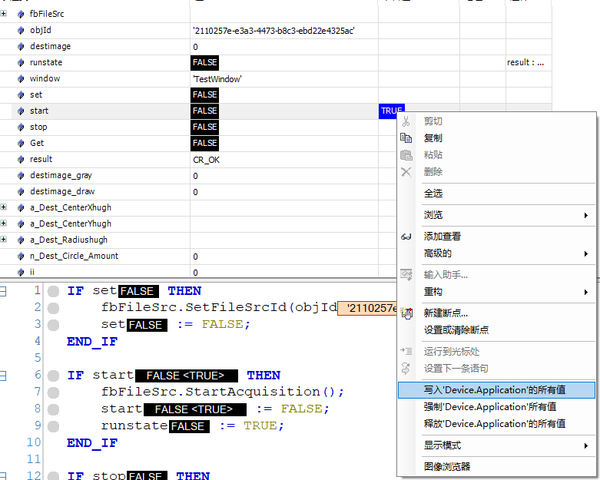
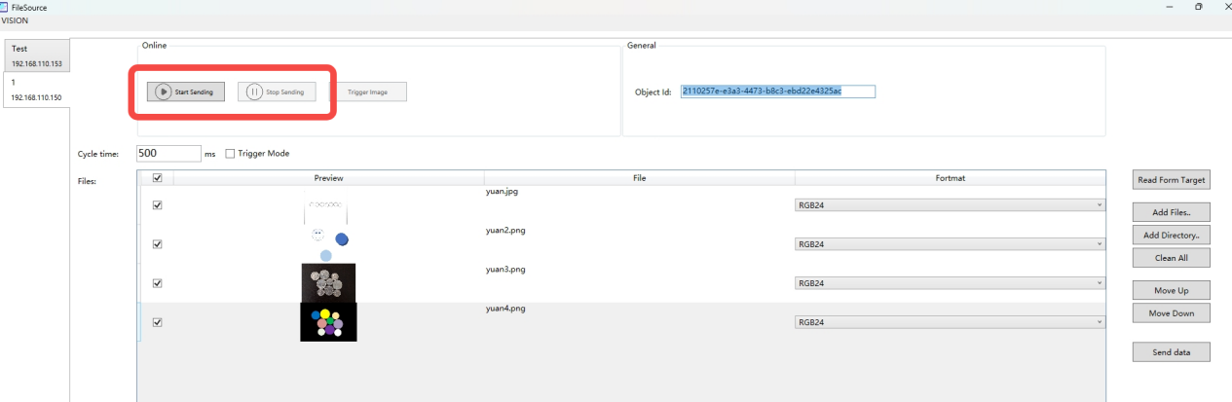

c. If Trigger Mode in FileSource is false, set the variables “Get” and “runstate” to true
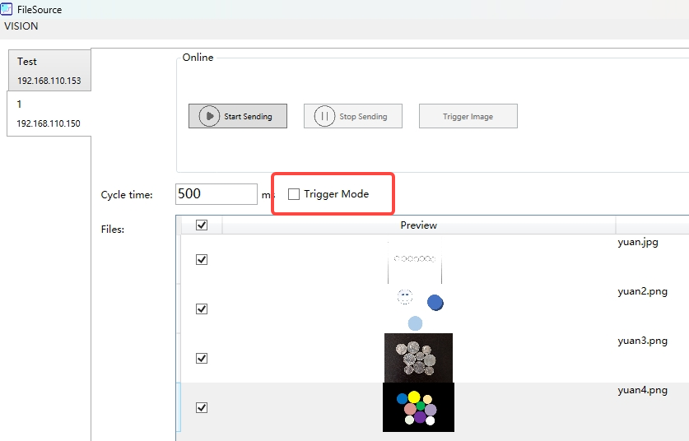
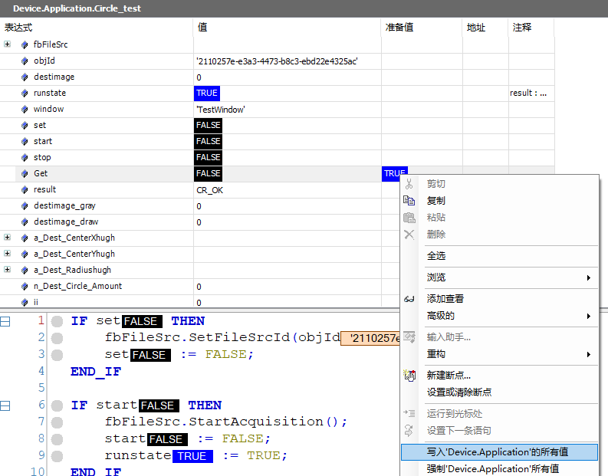

e. Click the image browser twice in the tool and separate the two windows
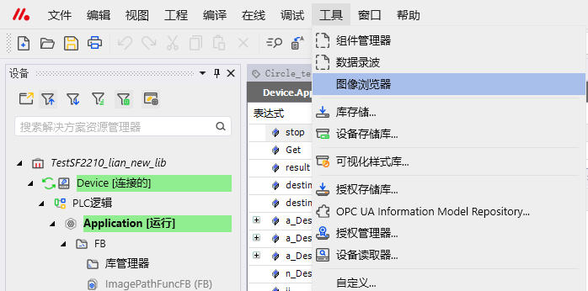
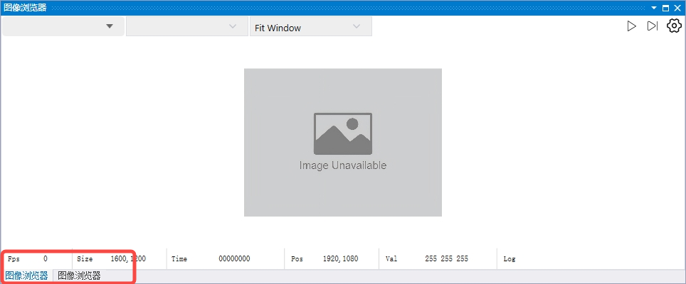
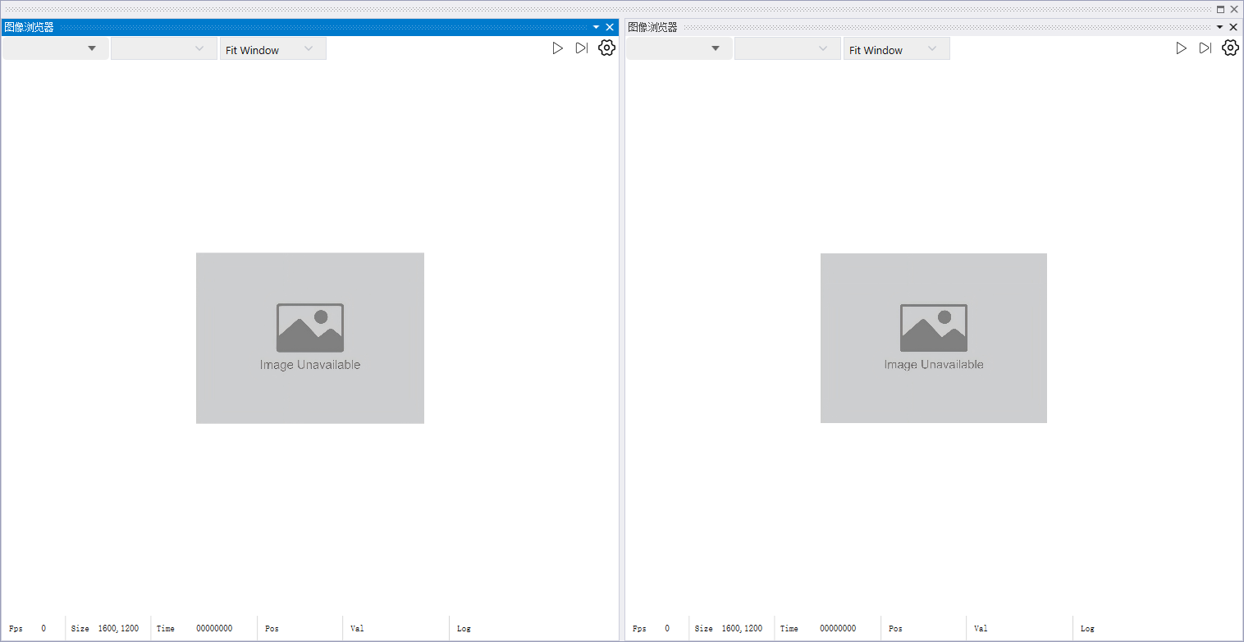

f. Select the currently running iComputer for both windows. One window is selected as testwindow, and the other window is selected as originwindow.
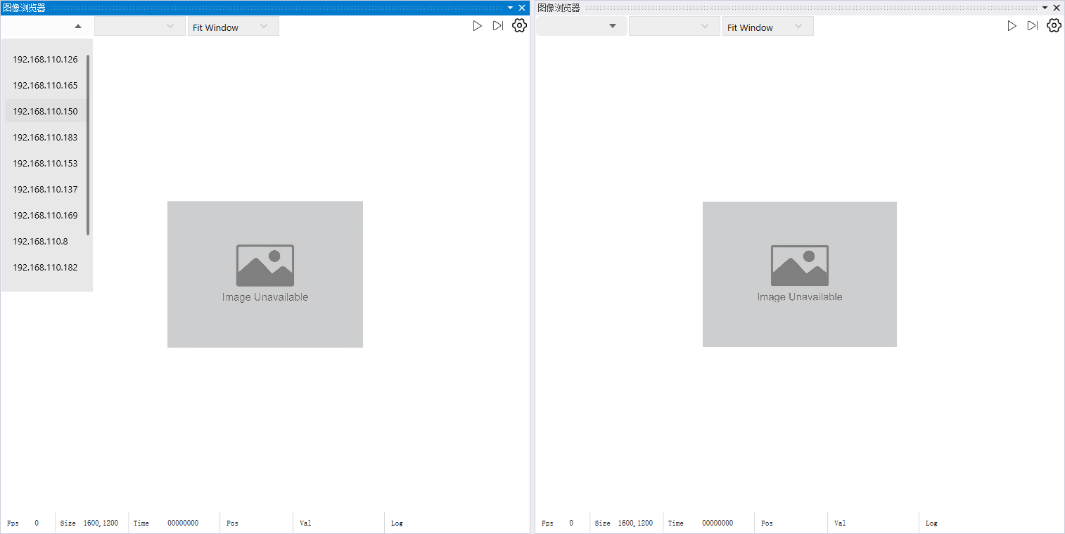
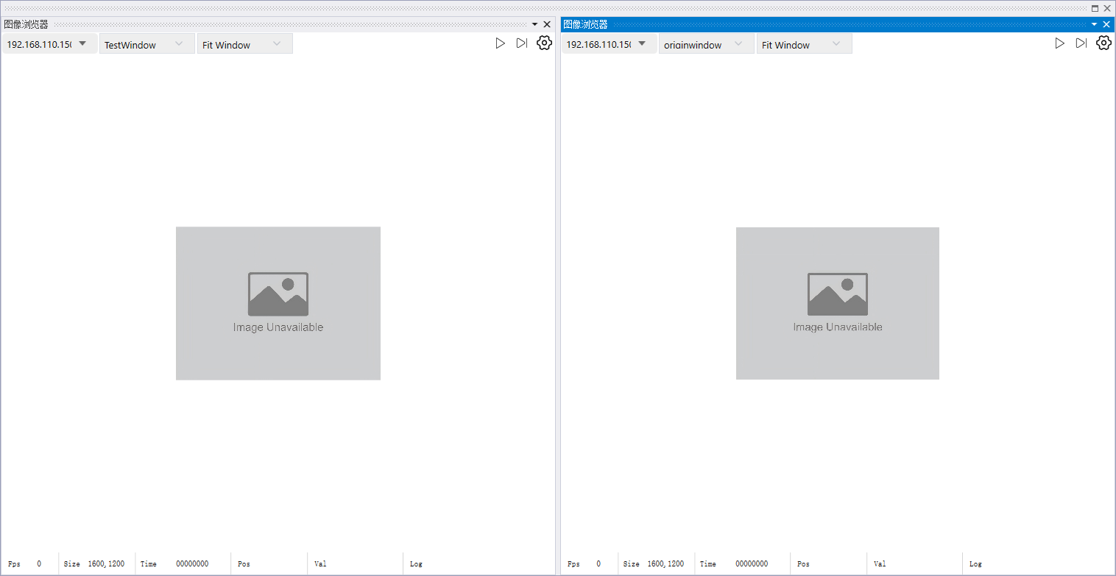

g. Click the two windows to run, and you can see the original image and the image processed by the vision operator, and the picture will automatically switch to the next one every 500ms
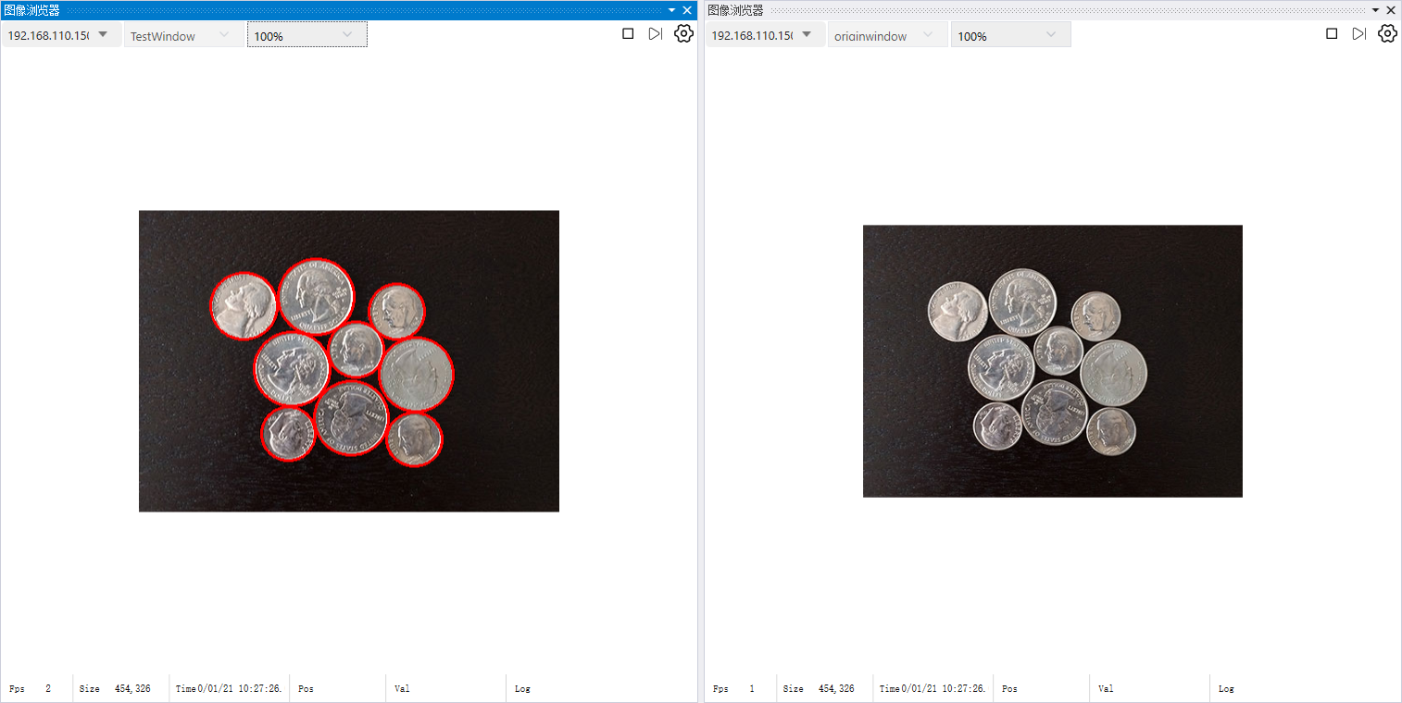
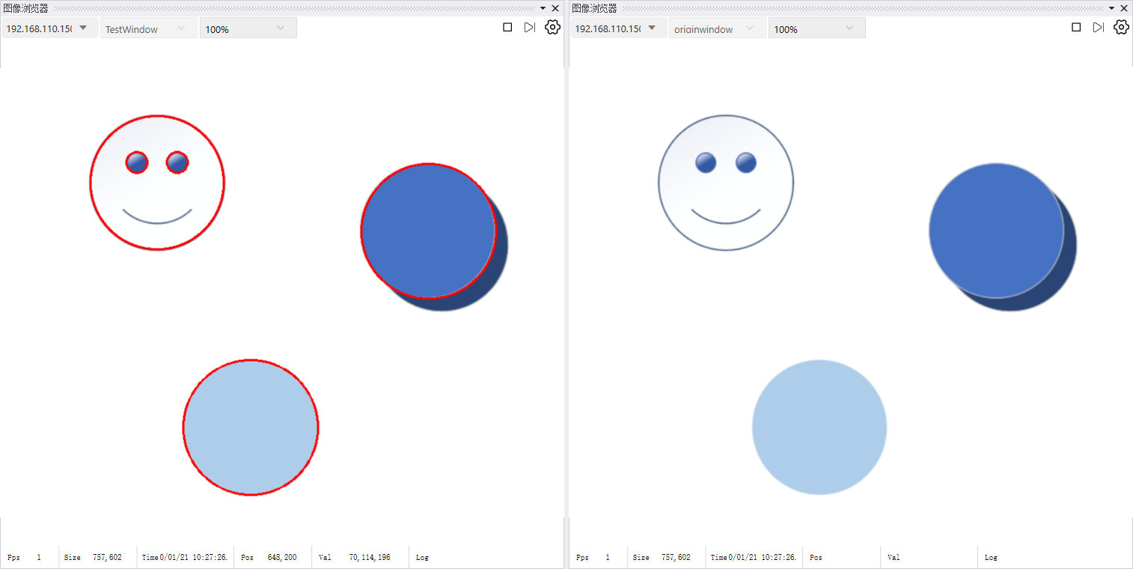
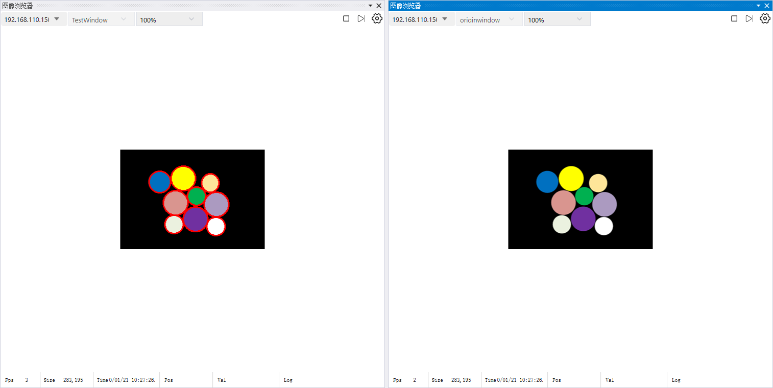
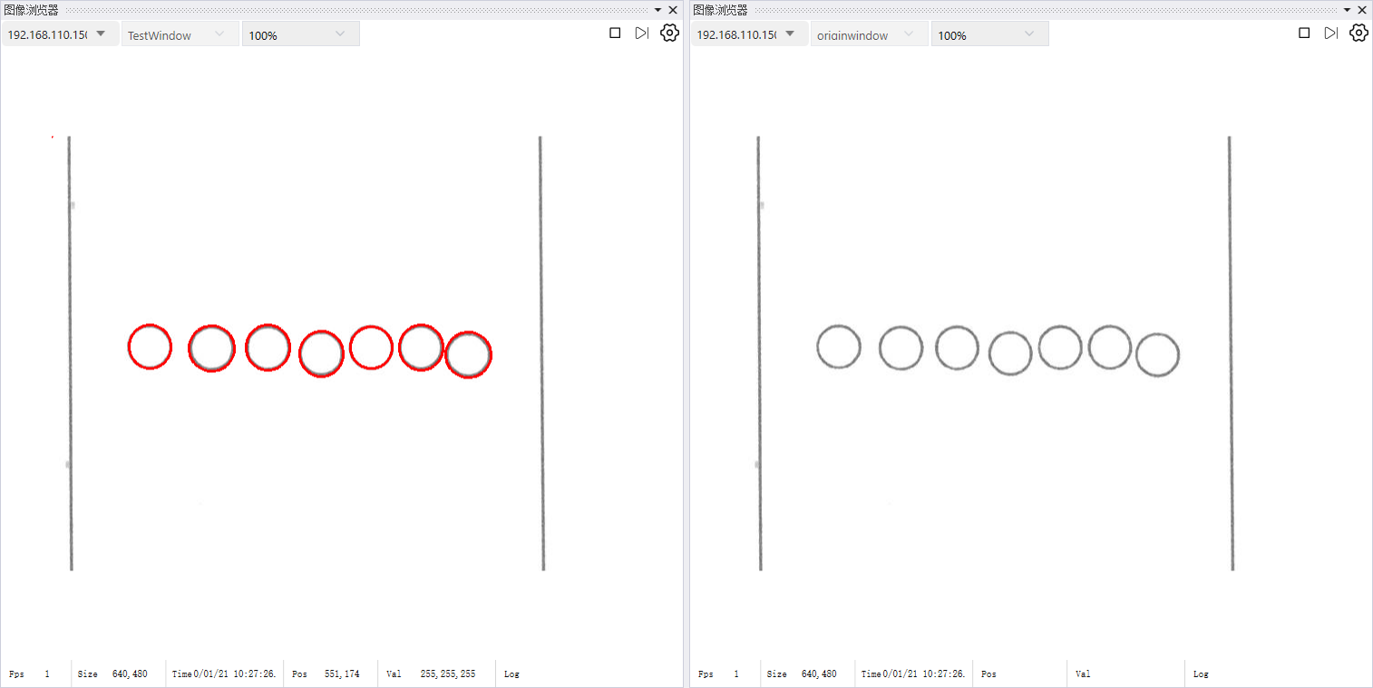

h. If Trigger Mode in FileSource is true, set the variables “Get” and “runstate” to true, click start sending, and click Trigger Image in FileSource.
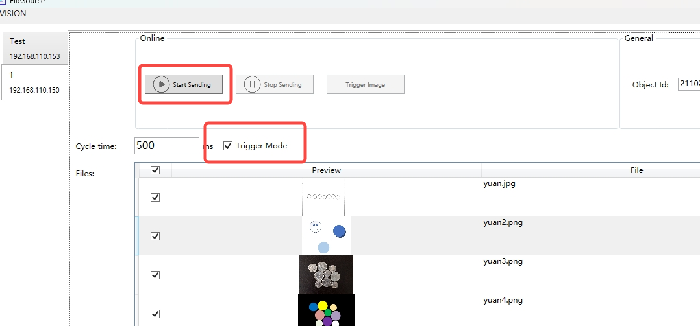

i. Click the image browser twice in the tool and separate the two windows




j. Select the currently running iComputer for both windows. One window is selected as testwindow, and the other window is selected as originwindow.



k. Click the two windows to run, and you see the original image and the image processed by the vision operator. Every time you click Trigger Image in FileSource, the image will switch to the next one.





II. Example
Name | SF2210 Version | ACP Version | Description
TestSF2210_lian_new_lib.project | sicomputervisionop_0.0.0-filelian2d06c307_amd64 | libacp_0.2.2-beat_amd64 | PLC Quick Start Project

Function introduction
1. Image acquisition from the file source
The image can be acquired via external/internal file source processing tools and input into the iComputer
2. Image processing by algorithm
The image can be processed by various algorithms and can be read and saved

Appendix

I. Function Introduction
See the following document for details
SF2210 Operator Library Interface Description (Chinese Version)-v20241129.docx

II. Support and Service
Sinsegye provides comprehensive support and services for the company's products and solutions, ensuring a fast and professional response to relevant issues.
Data Download
Our data download section covers a wealth of file resources, including application cases, technical documentation, and product descriptions, which meet your diverse needs.
Data download address: https://help.sinsegye.com.cn/
Get Support
Please contact us at any time for local support and service of Sinsegye products. You can visit our official website www.sinsegye.com.cn to see the branch address of Sinsegye and get more information about Sinsegye.
In addition, you can contact us by:
- Hotline: 400-013-2158
- E-mail address: support@sinsegye.com.cn

